Samajbandh Information
Project Locations -
📍Pune
- Sau Kendra, Balaji Nagar, Ghorpadi Gaon. 7058506833
- Asha Kendra, DLRC, Tapkirwasti, Baner. 7058536833
📍 Raigad
Nav-Nirmiti, Uddhar Village, Sudhagad, Raigad. 7058516833
📍 Gadchiroli
Satyagrah Manch, Shobha Nagar, Bhamragad. 7058326833

Why Samajbandh ?
Despite decades of progress, menstruation continues to be surrounded by silence, stigma, harmful traditions, and limited access to safe menstrual products. These challenges affect girls' education, women's health, dignity, and equal participation in society.
Founded in 2016, Samajbandh works with tribal and rural communities in Maharashtra to make menstruation a matter of health, dignity, and informed choice. Samajbandh is a volunteer based and youth led not-for profit organization that walks on constitutional values.
We believe that lasting change comes from within a community through its own collective initiative. Instead of imposing solutions, we strengthen local leadership and support communities in creating sustainable change.
'P For Periods' Awareness
- From 10 yrs experience, we believe that, Behavioural Change begins with scientific knowledge and the development of a scientific temper.
- Through the Arogya Samwadak Fellowship, 60 menstrual health educators across 22 districts of Maharashtra have conducted 4,000+ awareness sessions, educating 150,000+ adolescents and women.
- 80% of them now feel confident discussing menstruation openly at home.
Asha Pad Production Centers
- Using hygienic menstrual products can protect health, dignity, and confidence.
- Across 4 production centres in Gadchiroli, Raigad and Pune, Samajbandh transforms old clothes into reusable Asha Pads that have been distributed to 20,000+ tribal and rural women.
- Every woman also receives training to make her own Asha Pads, ensuring long-term sustainability.
- The stitching centers have employed 14 women full-time.
Kurma Sudhar Program
Samajbandh works in Gadchiroli to transform the Kurma - Period hut tradition, where menstruating women are isolated in a hut away from their homes. Women have no voice and choice in decision making. Thus to build a women led and women centric movement Samajbandh has identified and trained Arogyasakhi- in each village to lead the menstrual dialogue with various stakeholders of the community. A week-long residential camp has been conducted in 49 villages of Bhamragad to promote lasting social change.
As a result, around 10% of women now stay in their own courtyards instead of period huts during menstruation, and the practice of imposing fines for not following the custom has almost completely stopped.

Team
Full name: Sachin Asha Subhash
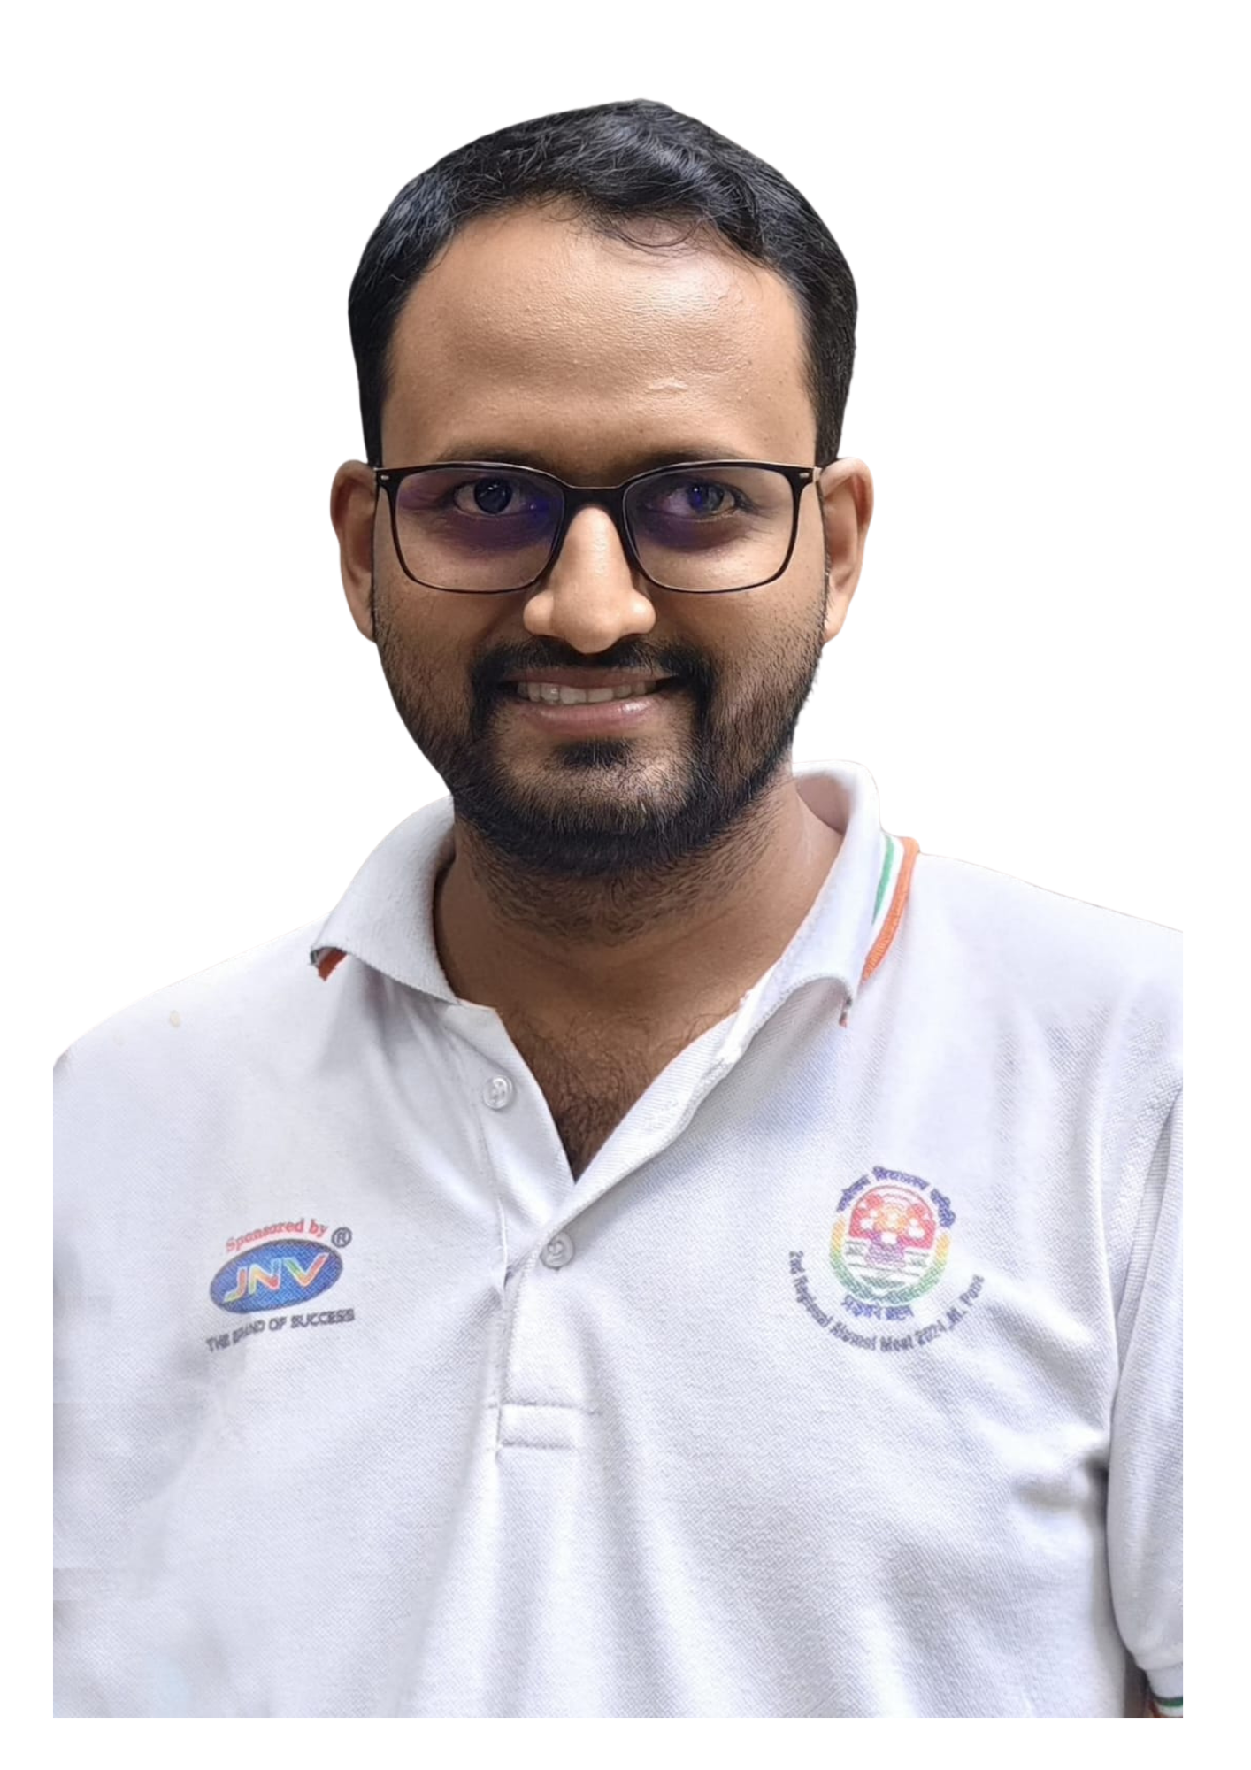
Name: Sachin
Mother Name: Asha
Father Name: Subhash
Designation: Founder and Trustee
Office Email Id
Office Phone No.:
Education:

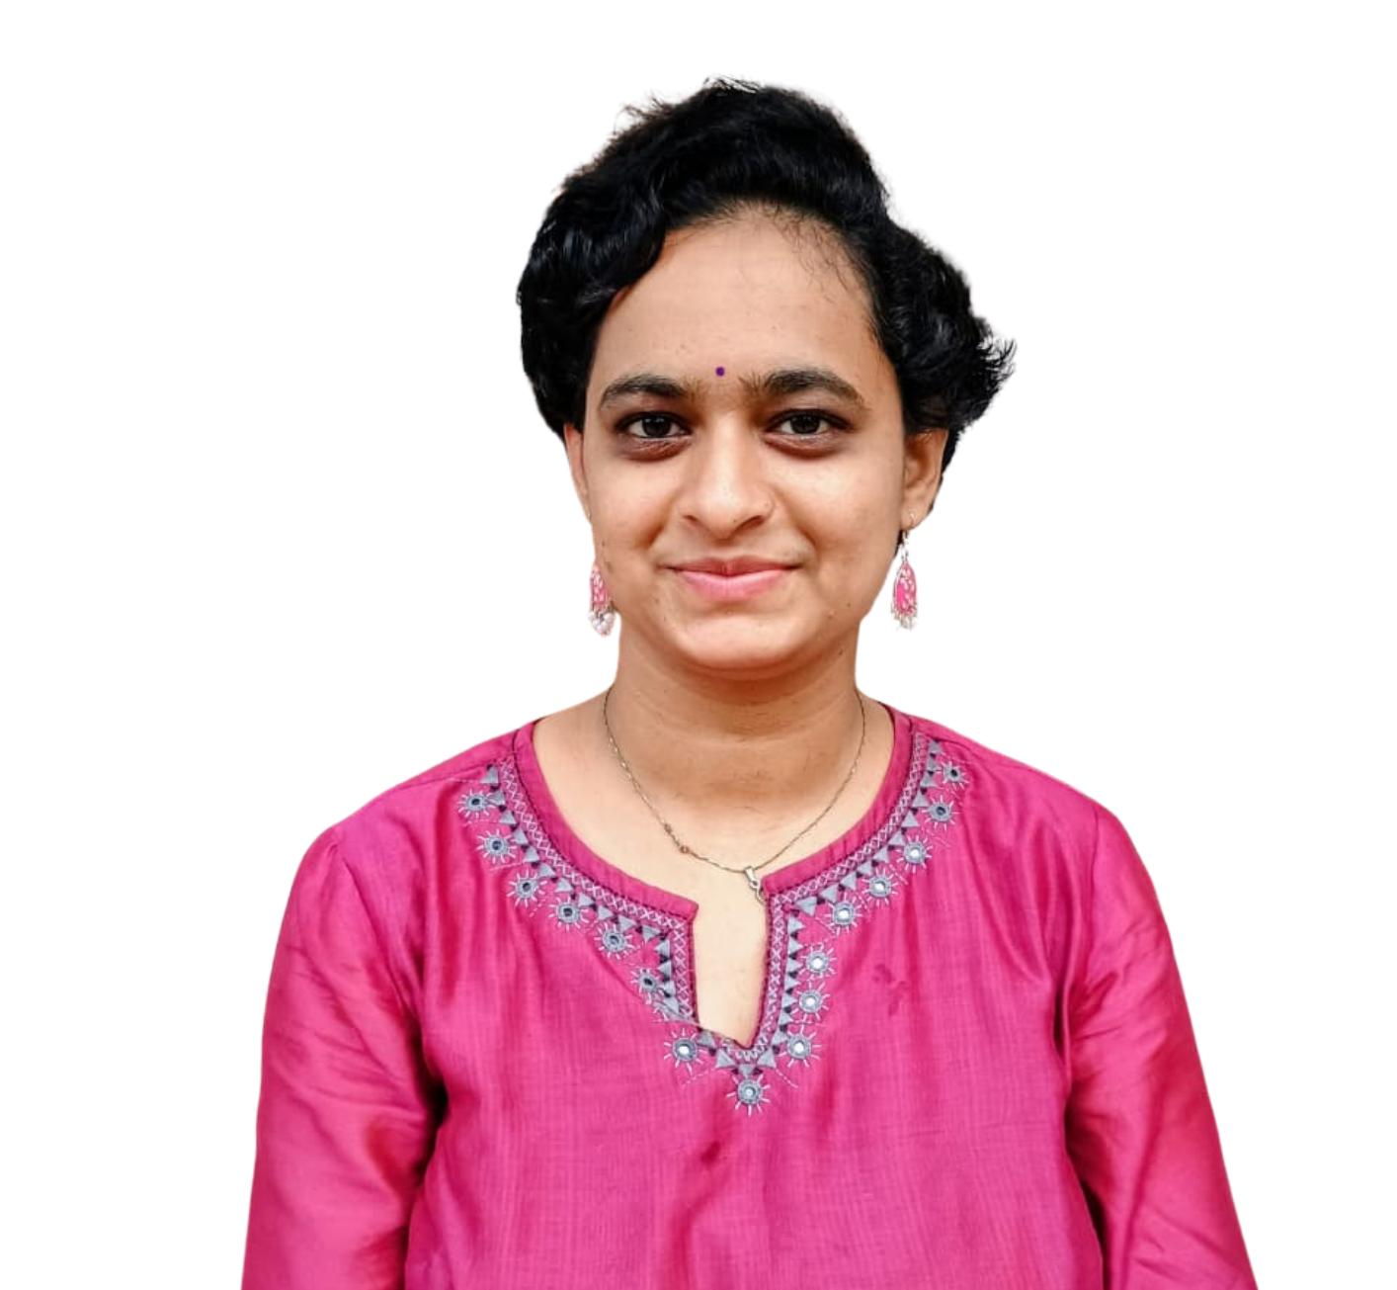
Full name: Sharvari Surekha Arun
Name: Sharvari
Mother Name: Surekha
Father Name: Arun
Designation: Trustee
Office Email Id
Office Phone No.:
Education:

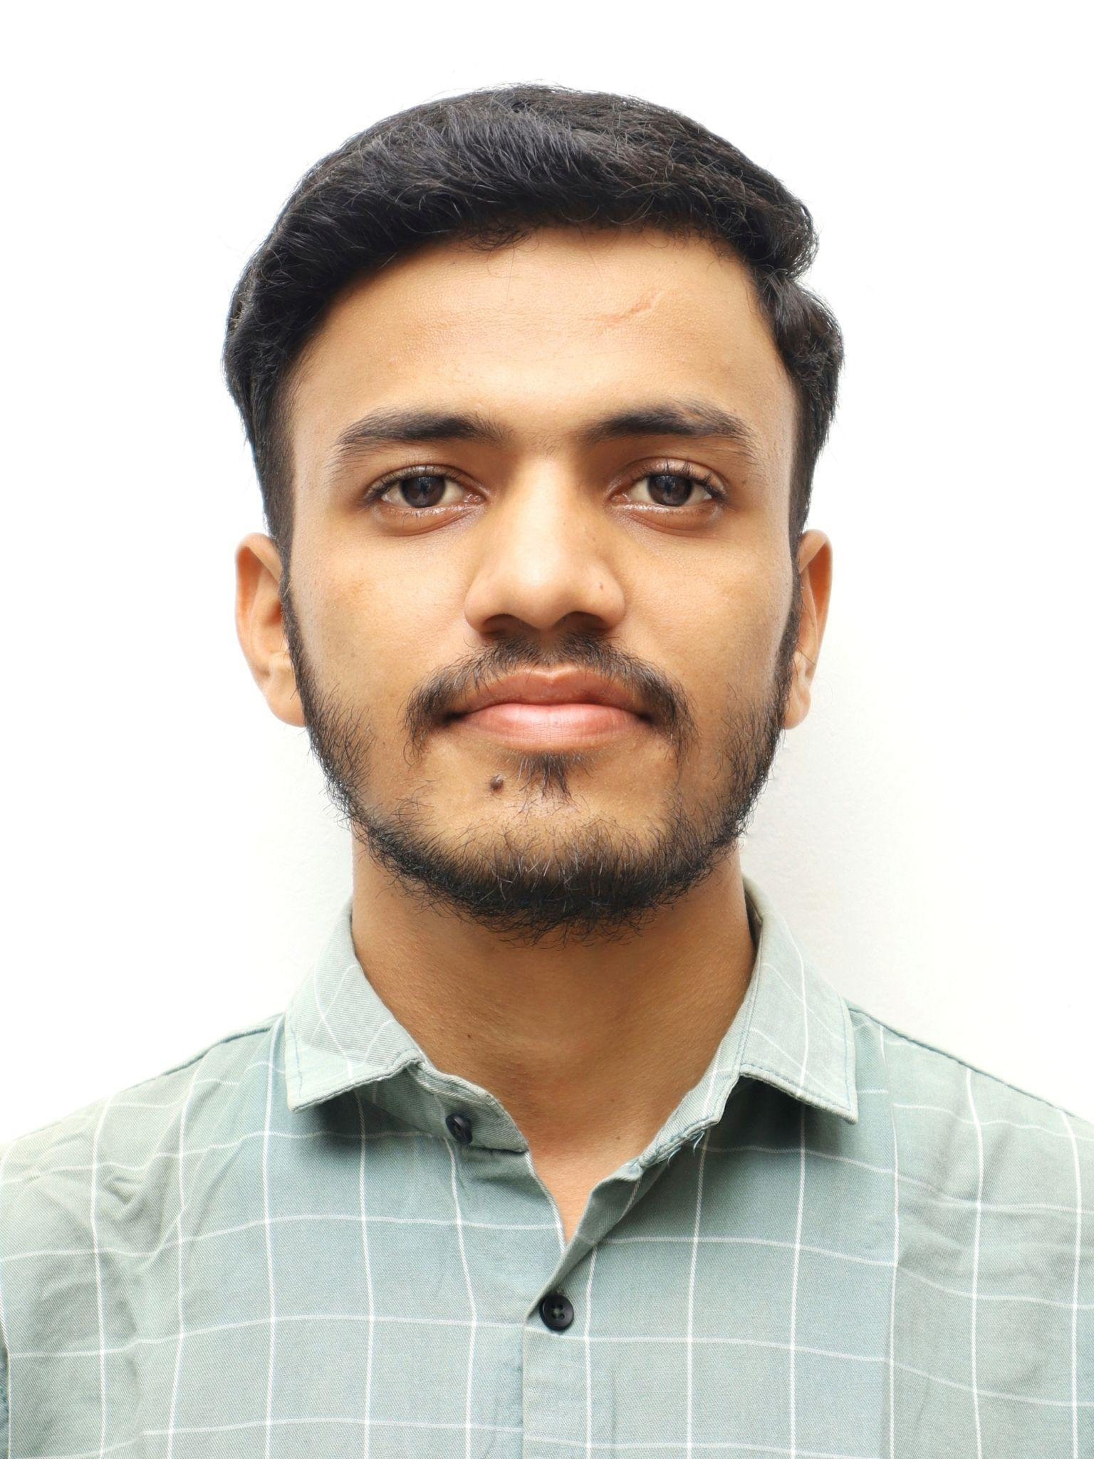
Full name: Prathmesh Rajashri Tanaji
Name: Prathmesh
Mother Name: Rajashri
Father Name: Tanaji
Designation: Project Co-ordinator
Office Email Id: prathmesh.samajbandh@gmail.com
Office Phone No.: 7058326833
Education: B.Sc. Statistics, MA Mass Communication

Full name: Prajwal Shalini Sadanand
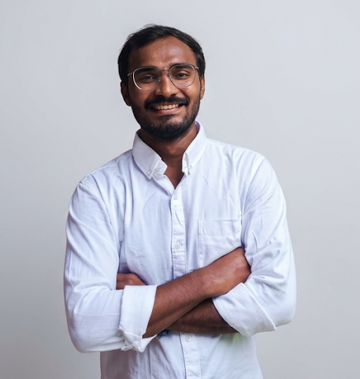
Name: Prajwal
Mother Name: Shalini
Father Name: Sadanand
Designation: Project Co-ordinator
Office Email Id: prajwal.samajbandh@gmail.com
Office Phone No.: 7058536833
Education: BSW, MSW

Full name: Rutuja Sushama Subhash
Name: Rutuja
Mother Name: Sushama
Father Name: Subhash
Designation: Project Co-ordinator
Office Email Id: rutujasamajbandh@gmail.com
Office Phone No.: 7058406833
Education: B.Sc Computer Science, Mathematics, Statistics and MA Development Studies

Full name: Nivedita Ranjana Prakash
Name: Nivedita
Mother Name: Ranjana
Father Name: Prakash
Designation: Program Co-ordinator
Office Email Id: niveditasamajbandh@gmail.com
Office Phone No.: 7058516833
Education: B.E Civil Engineering , MA Women's Studies

Programs
Name of the Program: Kurma Reform Program
Location: Bhamragad
Description: The programme addresses the discriminatory Kurma practice among the Madia tribal community in Bhamragad, Gadchiroli, where menstruating women are isolated in Kurma Ghars and face severe social restrictions. During the year, activities included the Satyache Prayog Shibir 7-day residential camp, menstruation and gender awareness sessions, distribution of Asha cloth pad kits, and training of Arogya Sakhis to lead sustained community awareness and behaviour change.

Name of the Program: MHM Awareness Session
- Location: Bhamragad
Description:

- Location: Raigad
Description:

Name of the Program: Arogya Samwadak Fellowship
Location:
Description:

Name of the Program: Workshops in Navnirmiti campus
Location:
Description:
- Satyashodhak Karyakrta Shibir: Samajbandh believes that meaningful social change is driven by committed volunteers with strong values, empathy and rational thinking. The Satyashodhak Karyakarta Shibir nurtures socially conscious youth by fostering sensitivity in everyday life, encouraging critical thinking, and strengthening their commitment to community-led social change.

- TOTO:

Name of the Program: Production unit
Description: Samajbandh transforms donated reusable cloth into Asha reusable cloth pads at production units in Pune (Ghorpadi, Baner) and Raigad, advancing sustainable menstrual hygiene while empowering local women through livelihood-focused pad-production.

Name of the Program: Samata Samwad Yatra
Location:
Description:

Name of the Online Program: Gender Vachan Katta
Description: The Gender Equality Programme promotes equitable, inclusive and discrimination-free communities by encouraging dialogue, critical thinking and collective action on gender and social justice.

During the year, it included Gender Reading Circles, the Samata Samvad Yatra, the Samata Challenge, and an online Navratri Awareness Campaign, creating spaces for dialogue, reflection and community engagement on gender equality and constitutional values.

Name of the Online Program: Navratri Nav-vichar Campaign
Description: Samajbandh’s Navratri Poster Campaign is a social awareness initiative that leverages the cultural significance of Navratri to confront gender-based inequality and hypocrisy in society.
While the festival celebrates Goddess Durga and honors young girls through Kanya Pujan, the campaign uses impactful visual posters placed in public and community spaces to highlight the stark reality women face daily—including domestic violence, menstrual taboos, safety concerns, and denied rights. By juxtaposing divine veneration with real-world mistreatment, the event sparks crucial public dialogue, challenging society to extend the respect given to female deities to all women in everyday life.

Name of the Online Program: Samata Social Challenge
Description: The Online Poster Sharing Campaign (Jan 3 – Apr 14) was a digitally driven social media initiative aimed at amplifying critical conversations around gender inequality, women's rights, and societal double standards.
Timed between the birth anniversary of social reformer Savitribai Phule (Jan 3) and Ambedkar Jayanti (Apr 14), two iconic dates rooted in social justice and equality, the campaign curated and reshared powerful visual posters from various established social awareness pages. By acting as a digital megaphone, the effort revived impactful existing messaging, widened its reach across online communities, and kept the dialogue on women’s rights active beyond festival seasons.

Impact Stories

Social Media Account
Linktree: https://linktr.ee/samajbandh
Facebook: https://www.facebook.com/samajbandh/
Instagram: https://www.instagram.com/samajbandh.india?stkn=MXNiaDhlOHBqYjBlMg==
Linkedin: https://www.linkedin.com/company/samajbandh-indi/?viewAsMember=true
Twitter:

Bank Details to Donation
ACC. NAME: SAMAJBANDH
KOTAK MAHINDRA BANK
SAHAKAR NAGAR BRANCH, PUNE
IFSC: KKBK0001803
ACC. NO.: 1145 30 4169
UPI ID: SAMAJBANDH@KOTAK

Awards & Conference
- Featured in a national report of ‘Antyodaya Based Best Practices’ in 2020
- Featured in a special story by NDTV for Kurma eradication work.
- Recipient of Loksatta – Tarun Tejankit 2024 by Indian Express group.
- Recipient of Deepstambh Yuva Prerna Puraskar by Deepstambh, Jalgaon.
- Recipient of Women Achievers Award by Pune Times Mirror newspaper.
- Recipient of Snehadhar Gaurav Puraskar by Snehalaya, Ahmednagar.
- Recipient of Navdurga Purskar by Lokmat media house, Pune.

MHM Master Trainer

